**Portfolio Project**

**Kevin Green**

**Colorado State University Global**

**Course Code: MIS581**

**Lisa Bryan**

**December 4th, 2022**

**ABSTRACT**

This research paper explores the impact commodity market positioning has on predicting future price. The commodity in focus is Crude Oil, one of the more popular traded commodity products in the world as it has a profound impact on our daily lives. Regulated exchanges such as the Chicago Mercantile Exchange generate a weekly report called the Commitment of Traders Report that shows the different positions held by traders. The CME created four main categories of traders based on their trading intent. The four categories include: Producers, Swap Dealer, Money Manager, and Other Reportables. Each of these groups utilize futures contracts to achieve a certain objective. For instance, Producers, like Chevron Corp, utilize futures to hedge adverse price movements in crude oil. Their intent is to sell crude at a higher price than the cost to extract, refine, and deliver the product. They may sell a futures contract to capitalize, or offset, the devaluing of crude oil.

The Commitment of Traders Report is the structured data source that was utilized in the research paper. The report is used and accepted by market participants and allow very little bias by the study. The data used for the study were from 2006 through August 2022. Since the data is structured as a time series it was important to capture a wide range of data that included several different market cycles, geopolitical events, and structural changes within the oil industry. The data is also available in real-time by the CFTC and this study may be replicated by others in a transparent manner. Before conducting the study, several different data exploration techniques were used to ensure normality with the data.  
 The research found that different categories of traders and their positioning has some predictive value in forecasting future prices of crude oil. Three different models were used in order to determine the effectiveness of the data and its predictive value. The first model used was a Linear Model. The second model used to explore the effectiveness of the data was a Neural Network. This neural network was basic in its construction and optimization techniques may improve the predictive value of the model. The last model utilized in the study was a Random Forest. The Random Forest model proved to be the most successful of all three.

Although these simplistic models showed effectiveness to predict future prices of oil, they may not be the most effective in a practical environment. Other external components may be needed to improve the effectiveness of these models, but the data is sufficient to be considered a valuable component of a broader system.

**INTRODUCTION**

The crude oil market has a profound impact on everyone’s life. From gasoline prices to the plastics used on a day-by-day basis, oil has been a staple commodity that has propelled the world’s innovation. To meet the needs of the consumer, viable and transparent market centers were created so businesses can buy and sell the commodity to carry out their respective business functions. According to IG.com (2022), the modern oil market can be traced to Baku in 1837, where the first commercial oil refinery was established to distil oil into paraffin.The market was needed so they would be able to distribute oil in an orderly fashion and to also provide price stability. Currently, there are several different international exchanges where oil is traded. In the United States, the most popular exchange is the Chicago Mercantile Exchange or the CME for short according to volume data provided by the CME Group. The CME provides a centralized marketplace where producers, institutional investors, and speculators can trade oil commodity contracts. The exchange provides traders the ability to transact business while also reducing or removing counter-party risk. Counter party risk is when another party associated with a financial transaction fails to provide the goods, services, or cash needed to meet the obligation of a contract.The CME reduces or removes this type of risk by ensuring that all trade commitments will be fulfilled by the exchange itself, an essential to building a reliable and liquid market.

Although the majority of the trades taking place in the Crude Oil markets are done by producers like oil drillers or commercial users like airline companies, the liquidity within these markets is provided by speculators. These traders are speculating on the price of the commodity going up or going down. Speculators use a wide range of techniques to predict the future price movement of oil.

The research project will use fundamental analysis, specifically, the CFTC’s Commitment of Traders Report dataset. The CFTC (2022) describes the report as: “The Commodity Futures Trading Commission relies on data collected from market participants to conduct all its mission functions including market oversight, monitoring for liquidity and systemic risk, oversight of market participants, regulatory compliance, and enforcement of the CEA” (CFTC, 2022, pg 1). The report provides a detailed breakdown of the market position of several different trader categories. Mark J S Keenan (2020) defines the different categories as follows:

**Producer:** A producer is an entity that primarily uses futures products to hedge the physical commodity in some fashion such as packing, production, handling or selling a commodity (Mark J S Keenan, 2020). The futures markets allow for Producers to manage the price of future deliveries of a good, making it easier to forecast expenses and revenue.

**Swap Dealer (SD):** A ‘swap dealer’ uses futures to offset risk with another counterparty like a hedge fund or large corporation to be net neutral on a particular position (Mark J S Keenan, 2020). For instance, they may have an OTC agreement with Kellogg’s to deliver oats to the company and to offset the delivery risk and price risk they may buy a futures contract that would allow them to take delivery or to at least offset price increases in the cash market. Typically, these dealers do not take the physical delivery, but their job is to accept obscure forward agreements and then use traditional financial instruments to offset that risk, usually for a small premium.

**Money Manager:** A ‘money manager’ is registered with the CFTC or some other regulatory body (Mark J S Keenan, 2020). Their primary goal is to speculate on commodity prices in the hopes of making a profit for their clients. They do not have any intention of actually receiving the physical commodity.

**Other Reportables:** If a trader does not meet the definition of a producer, swap dealer, or money manager, then they will be considered an Other Reportable (Mark J S Keenan, 2020). These traders are speculators in the marketplace but may still hold significant positions that could influence market prices significantly.

**OBJECTIVES**

Knowing the different traders that participate in the crude oil market and their sizable trading portfolios, their market position has the ability to influence future prices. The research project will utilize descriptive and predictive analytics to prove the CFTC Commitment of Traders Report has predictive value. Several different methods will be used to test this hypothesis including machine learning techniques. Several different models will be developed, tested, and validated to test their accuracy.

The ability to predict future crude oil prices would give a speculative trader the ability to implement profitable trading strategies (Mark J S Keenan, 2020). Also, producers could utilize the pricing model(s) to better hedge their positions, reducing unforeseen losses. Several different objectives will also be highlighted within the research project:

* Does Producer positioning provide any predictive value?
* Does Swap Dealer positioning provide any predictive value?
* Does Money Manager positioning provide any predictive value?
* Does Other Reportables positioning provide any predictive value?
* Is a combination of the different trader categories that provide any predictive value?
* If predictive value is identified, is it substantial enough to utilize it within a trading strategy?

Companies that utilize crude oil within their day-to-day business are always concerned about the volatility of prices which could impact the predictability of profitability or expenses. Having the ability to predict future prices may allow companies to effectively use their cash reserves to hedge unforeseen risk while also leveraging free cash for other opportunities, maximizing their resources. Organizations that can accurately predict future prices could also lower cost for the consumer, as well. When prices are uncertain, companies increase prices to cover unforeseen risk in the marketplace. Now, every market participant knows that there is no way to hedge every single risk in the marketplace, but having the ability to reduce the amount of unforeseen risk has value for both stakeholders.

Speculators, as well, could find ways to exploit a pricing model that could give them a subtle advantage to the broader market. Speculators have a disadvantage when trading the markets because they tend to not have the same resources as large organizations. With less information or data at their fingertips they have less insight into the market.

Predictive models would allow speculators to gain a slight advantage to the broader market, instilling confidence for traders. As stated before, speculators are key in providing liquidity in the marketplace. Without speculators, the market would be more volatile, erratic, and less transparent. Retail traders tend to have a difficult time when starting to trade futures because of the amount of leverage that is involved in the product and the wide-ranging swings that come from large institutional traders establishing sizeable positions. But retail traders have the ability to leverage these markets to enhance their market returns where traditional equity markets may not be able to match without substantial risk.

**OVERIVEW OF STUDY**

The study will focus on proving, with a significant amount of certainty, that market positioning has predictable value for forecasting future prices of crude oil. The research will utilize the Commitment of Traders report which is produced by the CFTC (CFTC, 2022). The study will focus on the long and short positions of each category of trader within the report and compare those variables to the price of crude on the day the report is released with the hopes of uncovering predictable value. Due to the dataset being time series, the sample size used for the research project will be between 2006 and 2022. This timeframe includes several macroeconomic events in an effort to minimize seasonality or bias towards very important events. The research assignment will use all quantitative data that is available to the public in order to accept or reject the null hypotheses proposed. Using standard statistical practices such as t-test, p-values, and RMSE we will have the ability to objectively assess the assumptions outlined within the proposed hypothesis. Several different sources will also be utilized to compare the results of this study to other industry accepted studies.

**RESEARCH QUESTIONS AND HYPOTHESES**

The ability to accurately predict future prices of equities, commodities, or any other asset class has been the crown jewel for market enthusiast and with the advances in technology and the democratization of data science tools individual investors can leverage data to attempt to accomplish this goal. Crude oil has been a very popular topic in the news as of late from consumers seeing gas prices rising, to energy companies maintaining current outputs instead of expanding due to the rapid shift in “Green” technology adoption and their fear of a significant reduction in fossil fuel demand. That being said, the consumers continue to be dependent on the fossil fuel.

The Commitment of Traders Report that is published on a weekly basis according to the CFTC (CFTC, 2022, pg. 1). and the goal of this report is to provide greater transparency within the commodity market. This report provides insights on the market positioning of several different trader classifications, displaying the number of contracts a trader class is long, short, and spreading. A long position means the entity has purchased the futures contract and is hoping the price of the commodity will increase over time. A short position means the entity has sold a futures contract short in the hopes of the price of the commodity to decline. A spread means an entity is both long and short a contract and is neutral on price movement. Typically, spread positions are done to neutralize price moves either to the upside or downside and may be necessary for large institutions who may have significant risk in their portfolio but does not wish to close out their underlying position, mainly due to tax consequences.

The research paper will review the impact the Commitment of Traders report has on future price movement if any. The following questions will be addressed throughout the research paper:

* Does Producer market positioning have an impact on future price movements of crude oil?
* Does Money Manager market position have an impact on future price movements of crude oil?
* Does Other Reportable market positioning have an impact on future price movements of crude?
* Is a combination of each trader category that could provide predictive value for the price of crude oil?

Ho: Trader market positioning does not have measurable influence on the future price of crude oil.

HA: Trader market positioning has measurable influence on the price of crude oil.

**LITERATURE REVIEW**

The Commitment of Traders Report has been a report that has been studied at length since its inception (Mark J S Keenan, 2020). There have been several different studies conducted to check its ability to predict or give insight into the commodity market. The article Commitment of Traders Basis, Behavior and the Issue of Risk Premia in Futures Markets describes the profitability of speculators and their ability to gain that profitability by placing well timed trades, but they may not be realizing the full potential of their risk due to risk premium in the marketplace being undervalued (Chatrath, A., & Liang, Y., 1997, Abstract). In essence, they may provide insights into trader sentiment, but their main function in the marketplace is to provide liquidity to hedgers, those that are utilizing futures contracts to offset the risk of the physical commodity price fluctuating dramatically. For instance, the article describes premium, or premia, as the following: “In the absence of premia, the difference between the current futures price and current spot price (the basis) of a storable commodity is determined by the cost of carrying the commodity, and any convenience yield associated with storing it” (Chatrath, A., & Liang, Y., 1997).This notion implies that Producers, or those that are using futures contracts to hedge the physical commodity, are doing so to protect risk and not to speculate on price movements. An interesting phenomenon has occurred in the last year where oil prices for near dated futures contracts are priced higher than further dated contracts. This means, the market has already priced in the cost to store the commodity, but there has been added premium due to demand side factors. In fact, producers have “over hedged” themselves and have been long excessive crude oil contracts due to two factors. Increase in demand and the fear of failing to deliver the physical commodity, which could lead to regulatory fees and penalties. Producers are offsetting that risk by leveraging long futures contracts to compensate for the potential of failing to deliver. Knowing these different dynamics, consider the first question that I proposed for the research project: ***Does Producer market positioning have an impact on future price movements of crude oil?*** The answer could be mixed based on the article. Producers are not intending to profit from hedging their physical commodity utilizing futures, but they could have an indirect impact on prices in the event of supply side market events like the Ukraine/Russia conflict, which has been responsible for over a 30% increase in price at the beginning of kinetic military operations.

Another question that I offered is “Does Money Manager market position have an impact on future price movements of crude oil?”. The impact that Managed Money funds have on certain commodities could be very substantial. Managed money can include CTAs/CTOs, ETFs, Mutual Funds, among other products which have a considerable amount of exposure to retail and institutional speculators and investors (Mark J S Keenan, 2020). The foundation of the market centers around the amount of capital deployed in a certain market. For instance, if a trader controls 60% of the overall market, they have the ability to impact significant market movements due to liquidity factors. Less participants in the marketplace can cause significant price movements.

Rafael Baptista Palazzi wrote in the article “Can we still blame index funds for the price movements in the agricultural commodities market?” that certain linear models can explain some correlation between speculator market positioning and price movements, but also nonlinear methodologies do not confirm a definite trend in the marketplace (Palazzi, 2020, Introduction). Other factors may play a role in providing predictive value but according to this study a simple linear model cannot be applied across all commodity markets. With focus on the crude oil market, the research project will provide a definitive answer into predictability or correlation of market positioning and price changes.

James Hamilton and Jing Wu noted in their article, Effects of Index-Fund Investing on Commodity Futures Prices, that “Barclays Capital estimated that exchange traded financial products following such strategies grew from negligible amounts in 2003 to a quarter trillion dollars by 2008.” (Hamilton, J. D., & Wu, J. C., 2015, Abstract). Highlighting the rapid growth of retail investor influence in the commodity market and how mundane market events could result in significant price movements as these funds attempt to gain exposure to commodities. Although the influx of assets provides greater liquidity into the marketplace, it also instills fear in other speculative traders who may be concerned around the rapid increase in volatility, causing them to lower their trading size and volumes. This example explains why markets may experience spikes in volatility resulting in provide moves in price.

**RESEARCH DESIGN**

**Methodology**

The Market Efficiency Theory contends that current prices within the marketplace reflect all available information, and there are no other ways to gain an advantage within the marketplace by analyzing new data to gain insights to outperform the market (Investopedia.com, 2022, Market Efficiency Theory,). This theory has been tested since the market has been modernized with technology that provides participants access to data within an instant. That being said, even though prices reflect all data that is available in the marketplace, not all participants are aware of the data that is available which is why traders are able to capitalize on both fundamental and technical analysis techniques. The Commitment of Traders report is the standard used within the commodity market to identify market trends by market participants. The use of this dataset provides a widely acceptable dataset that is used with a high degree of confidence by professionals within the industry.

The dataset is publicly available in real-time by the CFTC, so obtaining the dataset and testing the research questions provided by this research paper provides needed transparency for assessing the conclusions. The London Metal Exchange provides a similar report but due to our purposes, focusing on Crude Oil, their version of the Commitment of Traders Report is not applicable. The report is released at 3:30 p.m. Eastern time every Friday excluding any holiday disruptions (CFTC, 2022). To collect the data the researcher downloaded the dataset as a CSV directly from the CFTC website.

The Commitment of Traders report is a time series dataset, and the timeframe from July 18th, 2006, to September 27th, 2022, has been used to test the hypotheses offered in the research paper. This is a series dataset so selecting random sample dates would not be appropriate as it would degrade the testing methods. The timeframe selected includes several different economic, social, and geopolitical events that have impacted not only price, but market positioning.

**Methods**

Several different statistical test and models will be used to test the null hypothesis. The first statistical test that will be utilized is a simple Pearson Correlation test. Pearson Correlation is used to measure the linear correlation between two datasets. The Pearson Correlation does not automatically qualify or disqualify a variable’s effectiveness to creating a model, especially for other models like neural networks or support vector machines. The next statistical tool I will use is a T-test to test the Commitment of Traders dataset to ensure the data that is being used is “normal” and not an outlier which could impact the results of a model.

After completing these two tests, the research paper will then complete several different models to see if they’re effective in predicting the future value of oil prices. The first model, and arguably the simplest model, will be a linear model. Linear models will be used to test each of the research questions. A linear model will be created to test the value the Producer variable has on predicting oil prices. Next a linear model will be created to test the value of the Money Manager variable, and then the Other Reportables variable. The last model will utilize each variable to see if the combination of each variable will add some predictive value to future oil prices. Linear models work well when data is structured in a way that moves up or down over time. Sporadic data that is scattered or significantly distributed does not fare well when it comes to linear models because a linear model is trying to find the line of “best fit”. Some believe a better model can achieved by using neural networks, decision trees, or some other structure the focuses more on weighting the different input variables and considering seasonality or other time series trends.

The next model that will be created is a neural network model. Once again, a model will be used to test each input variable independently. The last model will utilize each variable to see if the neural network can find a combination of weights that could be used to predict the future value of oil. A successful test will be the difference between the predictive values verse the actual values, also known as residual. Once these values are known, a linear model can be used with the two values to see the RMSE and the R-squared values which would reflect the effectiveness of the models. There are several different ways to measure model performance, but I will stick with the major expected components in order to meet industry-based standards.

**Limitations**

Although greater transparency provides an even playing field for every market participant this dataset has some significant limitations. First and foremost, the dataset is published every Friday at 3:30 Eastern time, but it only reflects market positioning at the end of Tuesday’s market close. This means the data does not reflect market positioning in real-time and participants may have changed their positioning between Wednesday though Friday. This stale data could provide misleading assumptions and possibly cause an individual to place a trade that may be a jeopardy of a loss. The data also includes futures contracts and futures options contracts. The research paper only focuses on Futures contract positioning as they are more reliable in nature than futures options. Institutional traders tend to use futures options to hedge their core position so the data could be misleading if included in the research paper.

**Ethical Considerations**

From an ethical standpoint, the data that has been provided by the CFTC is created to provide greater transparency in the commodity trading markets.Before the report, it was easy for traders to “manipulate” the market by placing trades that may influence other traders in the marketplace. This report also allows regulators to identify potential risk within the marketplace from one firm or entity. Traders have advocated for a daily update on market positioning as technology improvements have given regulators the opportunity to gather and disseminate information in a rapid fashion, but there has not been much support for larger traders within the industry.

Also, institutional trading firms had access to this position data and would charge retail investors a fee for such access. They would also use the data to their own advantage to create investor reports, also to place their own proprietary trades. So, from an ethical standpoint, since the information is publicly available it provides retail traders the ability to have the same access that others with significant amount of capital would have. From a standpoint of creating statistical models to gain an advantage in the marketplace, it is already widely used in the institutional trading world, so it would only seem appropriate that retail traders are able to develop similar models to gain insights in future trends. Institutional traders will always have the advantage of having access to non-public information due to the relationships they have built with large traders. With the ethical considerations outlined, the research paper is geared to either accept or reject the notion that a significant relationship between market positioning and crude oil prices. The goal is to provide the reader with the ability to use the findings within the research paper to compliment their current trading strategy and dispel some preconceived notions on the influence large institutional traders or producers have on commodity prices.

**FINDINGS**

When testing the dataset for normality the first item completed was a simple t-test on the price variable to ensure normality of the data. The t-test found a p-value of 2.2e-16 with the 95 percent confidence interval between 70.68419 and 73.80152, the sample estimate mean is 72.24285 which shows the price variable is normally distributed and appropriate for the research paper.

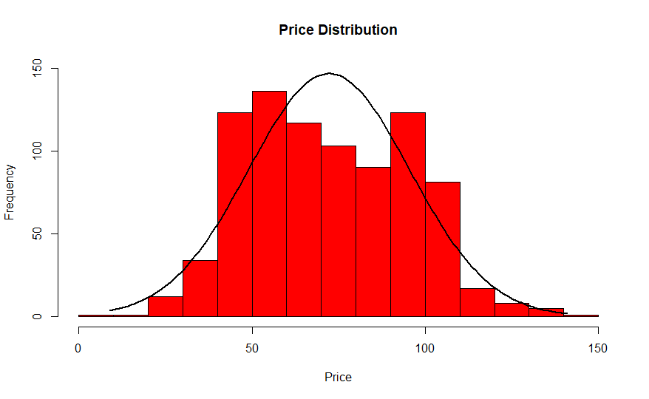

A Pearson Correlation test was also completed on the dataset to identify any collinearity between two variables. Some of the outstanding results of this correlation test is the fact that none of the variables had more than an absolute value of 54.175% correlation with price. Although this can be discouraging, quality models are built on assessing the relationship multiple independent variables have on the independent variable.

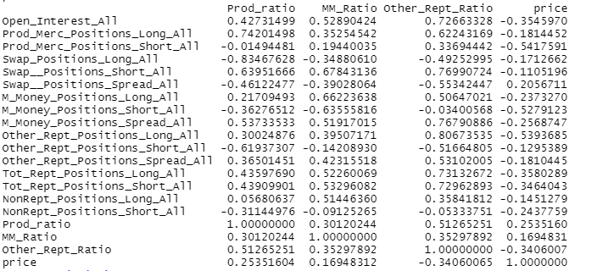

**Linear Model Results**

A linear model was created to show the predictability value of the independent variables compared to the dependent variable Price. The model was trained on a training dataset that included 639 of the 852 observations which equates to 70% of the total dataset. The results are as follows:

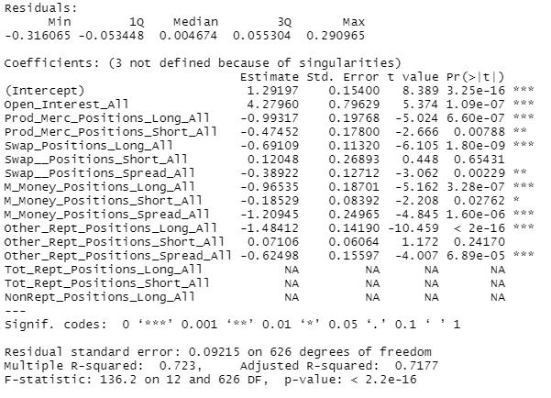

When reviewing the results, the data identified the following independent variables that have significant impact on the model. We identify significant by the prevailing p-values for each variable. Prod_Merc_Position_Long_All (Producer Long Positions), M_Money_Positions_Long_All (Money Manager Long Positions), and Other_Rept_Positions_Long_All (Other Reportable Long Positions) have a significant impact on the overall model. The model resulted in an Adjusted R-squared value of 71.77% which equates to the quality of the model. Although the model performed better than an Adjusted R-squared value of 50% which is the equivalent of a coin flip, the quality of the model is below industry expectations.

**Means Squared Error 901.5258**

**Root Mean Squared Error 30.02542**

The lower the value the better the model is at predicting price. The residual standard error shows some success with the model along with the R-squared values. Like with all data, we do see a small number of outliers within the data that can impact the accuracy of a model.

**Neural Network Results**

The dataset was also tested with a simple Neural Network to see if machine learning techniques could improve the predictability value of the independent variables. The Neural Network was created in R Studio with the neuralnet package. The model had 19 input layers, 10 hidden layer 1 nodes, 5 hidden layer 2 nodes, and 2 hidden layer 3 nodes to ensure accuracy of the model. The result of the neural network is as follows:

**Mean of Squared Error 32.2697**

**Root Mean Squared Error 5.659238**

Utilizing the “olden” function within the “NeuralNetTools” package the independent variables showed the following importance on the model:

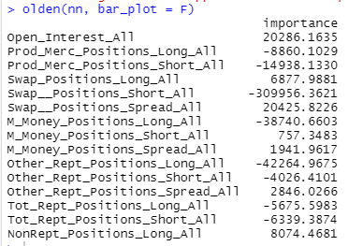

The result of this summary shows Swap Position short, Other Reportable Long, and Managed Money Long positions had a significant impact on the model’s accuracy.

**Random Forest Results**

The Random Forest model provided the best accuracy out of each model used in the study. The Random Forest was created in R Studio by using the “randomForest” package. The model had 10,000 trees to start the model and was fitted with the training dataset. The result of the model is as follows:

Mean of Squared Error: 31.14116

Root Mean Squared Error: 5.580426

Utilizing the Importance function within the “randomForest” package the independent variables showed the following importance on the model: 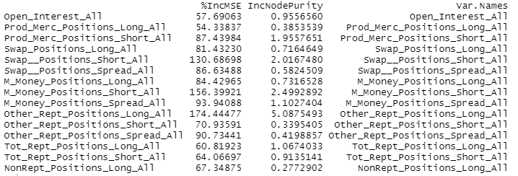

**Summary of Results**

|  |  |  |  |
| --- | --- | --- | --- |
| **Metric** | **Linear Model** | **Neural Network** | **Random Forest** |
| MSE | 901.5258 | 32.2697 | 31.14116 |
| RMSE | 30.02542 | 5.659238 | 5.580426 |

Based on the accuracy of all three models that were explored, linear regression, Neural Network, and Random Forest, the null hypothesis: “Trader market positioning has a significant impact on the future price of crude oil”, has been accepted. All three models showed the ability to predict future values of crude oil with more than 74% accuracy. The Root Means Squared Error values for each of the models are acceptable based on industry standards. The research paper tested the standard framework of each model without removing or replacing any independent variables or implementing any optimization features. Utilizing optimization features may improve the accuracy of each model.

**CONCLUSION**

Although simplistic models such as linear regression may not prove to be the best to predict future values of oil based on the Commitment of Traders report, it does provide some value for those looking to incorporate the report into broader models. The crude oil market, among others, are influenced by market participants and the basic forces of supply and demand. The Commitment of Traders report interprets supply and demand by highlighting market participant positioning as a proxy to convey demand side influences by using quantitative data.

Once again, Market Theory economics believes that current prices, regardless of the market, reflects all available information and even though we found predictive value in the Commitment of Traders report, it does not fully explain current pricing. Other influences such as news can have a dramatic impact on market pricing and that information may impact current prices more than when the Commitment of Traders report is released. Also, due to the delay of the release of the report, their may be a decaying factor associated with the information contained in the report due to these other factors described.

**RECOMMENDATIONS**

For an organization or retail trader that is looking at incorporating the Commitment of Traders report into their trading strategy or utilizing it within a current price predicting model there is value of using the contents within the report based on the finding of the research study. Independent variables such as Producer Long position, Money Manager Long Position, and Other Reportable Long Positions have proven to have some predictive value within the models explored within the research study. Based on the model techniques, Random Forest, appears to be best performing model out of the three and tends to be a popular framework for quantitative traders. As the Commitment of Trader report evolves and more market participants enter the marketplace the influence of each independent variable will change over time and a key obstacle that quants will need to address is the ability to scale the data in a way that minimizes bias. For instance, potentially exploring ratios to reflect the net positioning of a trader class or some other weighting mechanism to reduce bias. For example, as the market continues to evolve over time Producers will represent a smaller portion of total open interest. Investors continue to gain access to commodity markets either directly or indirectly, but the amount of land to produce goods is finite, so over time Producers’ share of total Open Interest will degrade, although they’re the biggest component within the futures markets to hedge risk for physical crops or goods.

**REFERENCES**

*Chatrath, A., & Liang, Y. (1997). Commitment of Traders, Basis Behavior, and the Issue of Risk Premia in Futures Markets. Journal of Futures Markets, 17(6), 707–731.* [https://doi.org/10.1002/(SICI)1096-9934(199709)17:6<707::AID-FUT5>3.0.CO;2-I](https://doi.org/10.1002/(SICI)1096-9934(199709)17:6%3c707::AID-FUT5%3e3.0.CO;2-I)

CityIndex UK CD. (n.d.). *Commodities trading explained - city index UK*. Trading Explained - City Index UK. Retrieved October 30, 2022, from https://www.cityindex.com/en-uk/trading-academy/courses/introduction-to-financial-markets/trading-commodities/#:~:text=What%20moves%20commodities%3F%201%20Seasonality%20Commodities%20are%20exposed,Commodities%20are%s20valuable%20resources%20in%20economies%20worldwide.%20

*Commitments of traders*. CFTC. (n.d.), from <https://www.cftc.gov/MarketReports/CommitmentsofTraders/index.htm>

*Fernando, J. (2022, November 3).* *R-squared formula, regression, and interpretations*. Investopedia, from https://www.investopedia.com/terms/r/r-squared.asp

*Fundamental analysis*. Corporate Finance Institute. (2022, January 29)., from https://corporatefinanceinstitute.com/resources/knowledge/trading-investing/fundamental-analysis/

*Hamilton, J. D., & Wu, J. C. (2015). Effects of Index-Fund Investing on Commodity Futures Prices. International Economic Review, 56(1), 187–205*. <https://doi.org/10.1111/iere.12099>

*IG. (n.d.). History of crude oil. IG.,* from https://www.ig.com/uk/commodities/oil/history-of-crude-oil-price

*Introduction to T-test theory and use cases*. Qualtrics. (2022, October 26)., from https://www.qualtrics.com/experience-management/research/t-test-analysis/

Mitchell, C. (2021, November 15). *Introduction to counterparty risk*. Investopedia., from https://www.investopedia.com/articles/optioninvestor/11/understanding-counterparty-risk.asp

*Overview. Administration Guide - Overview*. (n.d.)., from <https://docs.rstudio.com/ide/server-pro/latest/database/database.html>

*Power, G., & Robinson, J. C. (2013). Commodity futures price volatility, convenience yield and economic fundamentals. Applied Economics Letters, 20(11), 1089–1095.* <https://doi.org/10.1080/13504851.2013.788775>

*Root mean square error (RMSE)*. C3 AI. (2021, September 28). From https://c3.ai/glossary/data-science/root-mean-square-error-rmse/

Keenan, Mark J. (2020). *Advanced positioning, flow and sentiment analysis in commodity markets: Bridging Fundamental and technical analysis*. Wiley.

*Palazzi, R. B., Figueiredo Pinto, A. C., Klotzle, M. C., & De Oliveira, E. M. (2020). Can we still blame index funds for the price movements in the agricultural commodities market? International Review of Economics and Finance, 65, 84–93.* <https://doi.org/10.1016/j.iref.2019.10.001>